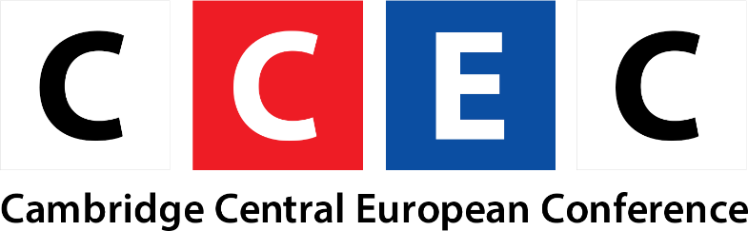

Cordially Invites You to
V4 Ambassadorial Roundtable:
Central European Perspectives on the Challenges of COVID and Brexit

Cambridge Central European Conference 2021, marking the 30th anniversary of the Visegrad Cooperation, brings together Central European perspectives on the two most topical issues nowadays, the COVID-19 and Brexit, via two roundtable discussions, reflecting on the important developments and common challenges in the region. The V4 Ambassadorial roundtable will be followed by a V4 Academic Roundtable on 18th March 2021.

Speakers:
H.E. Dr. Arkady Rzegocki, the Ambassador of Poland to the United Kingdom
H.E. Dr. Ferenc Kumin, the Ambassador of Hungary to the United Kingdom
H.E. Dr. Robert Ondrejcsak, the Ambassador of Slovakia to the United Kingdom

Moderator:
Dr. Zsuzsanna Varga, Lecturer, University of Glasgow

The introductory statements by the Ambassadors will be followed by a discussion with the moderator and Q&A.

Date: 4th March 2021
Time: 5-7pm (GMT), 6-8pm (CET)
Venue: Zoom (Please register for the event via the following link)
https://cam-ac-uk.zoom.us/webinar/register/WN_wkt4An7ATKq61ztRJj_-Fw

The event is organised in partnership with the Department of Central and East European Studies (University of Glasgow), Cambridge Polish Studies and Cambridge Committee for Russian and East European Studies (University of Cambridge). The conference partners include Czech and Slovak Society at the University of Cambridge and Central and East European Studies Society at the University of Glasgow.
If you have any questions, please contact the conference coordinator, Jakub Csabay, at jc2043@cam.ac.uk

